**Coaching Staff:**

**The director and coaches at the Patriots Softball Camp are some of the most talented in the industry. Our coaches all have college and/or high school coaching experience.**

**Stephani Moore-The Camp Director**

**Currently Assistant Coach, American Heritage**

-2x State Champions 6A

-2x State Runner up

-Coached Gatorade Player of the Year, Jenna Goodrich

**Former Pro Coach, PA Rebellion**

-Placed fourth in the National Pro Fastpitch League

**Former College Coach, California University of PA**

-.750 winning percentage (239-79), 6 NFCA All-Americans, 26 All Region players

-49 All PSAC players

-8 COSIDA All-Americans

-8 NCAA tournament appearances

-4 All-Region pitchers

-4 COSIDA Academic All American pitchers

-11 All PSAC pitchers

-5 PSAC Pitchers of the Year

**Brianna Stella-Coach**

**Current player at the University of Montevallo**

-3 year starter centerfield/first base

-Peach Belt President Honor Roll

**Graduate of St. Thomas ‘16**

**-**2014 Class 7A State Champion

-3x Sun Sentinel first team

-First team All-State (centerfield)

-3x Miami Herald first team All County

**Former and current college/high school players will also be assisting in coaching.**

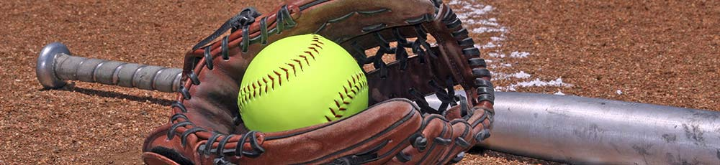

**Camp Objective**

The objective of the Patriots Softball Camp at American Heritage is to provide each participant with an enjoyable learning experience in the fundamentals of softball. Campers are grouped by age and experience; and receive instruction as an individual, in small groups, and as a team. Top level instruction is provided by a former pro coach, former college coaches, current college players, and current high school players. Campers will be instructed in softball fundamentals, including: hitting, pitching, infield, outfield, catching, base running, and overall game specific skills.  A combination of drills, competitions, and games make for a fun, instructional week of softball at the Patriots Softball Camp.

**Equipment needed:**

-Glove

-Batting helmet

-Facemask (optional)

-Bat/batting glove

-Cleats AND tennis shoes

-Catching gear (for catchers only)

-Water bottle

-Sun Block

-Extra set of clothes

-Bathing suit, flip-flops, & towel

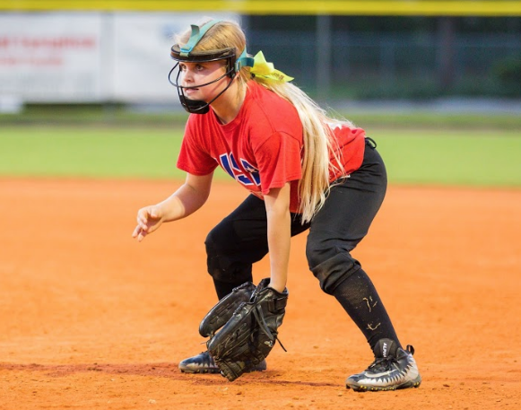

**PATRIOTS SOFTBALL**

**CAMP**

**at**

**American Heritage**

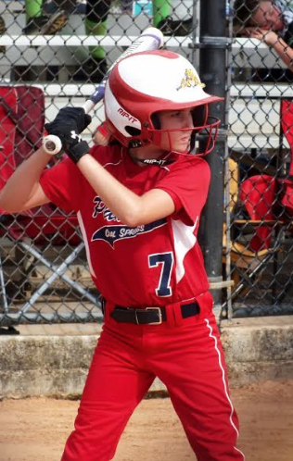

**Dates:**

Week One: 7/8 - 7/12

Week Two: 7/15 - 7/19

Week Three: 7/22 - 7/26

**Hours:**

8:45 am - 3:45 pm

**Ages:**

6-13 years old

**For additional information, team discount information or to register, call:**

**954-472-0022 ext. 3043**

or

**www.ahsummerprograms.com/camp**

**Camp Focus:**

**-**Developing fundamental softball skills

-Throwing & catching mechanics

-Hitting/bunting fundamentals

-Defensive skills/strategies

-Offensive skills/strategies

-Base running

-Speed and agility training

-Fundamentals of team concepts

-Live demonstrations of drills

-Participation in individual and group drills

-Creating a fun and competitive environment that will foster a love and passion for the game!

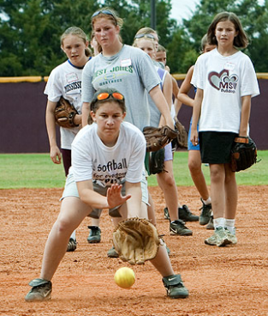

**Tentative Daily Schedule**

**8:00-8:45 am   Arrival**

**9:00 am   Stretch/Warm-up**

**9:15 am   Session I**

**10:30 am Cabin/Snack/Film**

**11:00 am Session II**

**12:15 pm   Lunch (provided)**

**1:00 pm   Pool Session**

**2:00 pm   Session III\***

**3:45 pm   Dismissal**

**Schedule subject to change due to weather.**

*Special camp activity one day per week

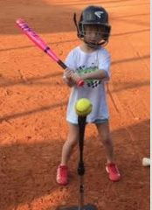

**Camp includes:**

**-**Individual skill/position training

-Team concepts & strategies

-Indoor facility for inclement weather

-Free morning care starting at 7 am

-After care available (add'l fee)

-Lunch & morning snack

-Camp t-shirt

-Pool time

-Free bus transportation:

Aventura, Coral Springs, Emerald Hills

Ft. Lauderdale, Hallandale, Hollywood,

MIramar, Parkland, Pembroke Pines,

and Weston

Cost: $480.00/week

For **team discounts** and any questions, please call or email:

**954-472-0022 ext. 3043**

**stephani.moore@ahschool.com**

